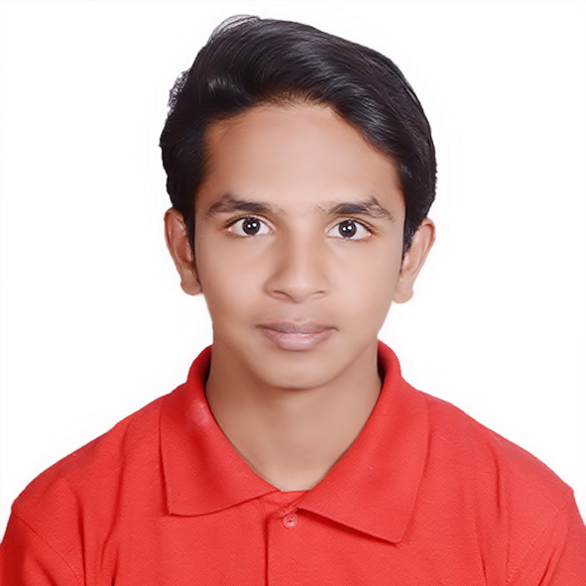

**CHINMAY NIMKAR**

**E-mail:** [**chinmaynimkar26@gmail.com**](mailto:chinmaynimkar26@gmail.com)

**Ph: +918888586572**

|  |
| --- |
|  |

**RESUME**

**Objective** :- To work in a stimulating environment where I can contribute my skills and grow professional and satisfying the goal of the organization, this can utilize my talent to the maximum by putting me in to a challenging and dynamic job providing me enough space to grow.

**Educational Qualifications :-**

|  |  |  |
| --- | --- | --- |
| **Examination** | Board/University | Year of Passing |
| S.Y. B.com | University of Pune | Appearing |
| H.S.C | Maharashtra State Board Pune | 2013 |
| S.S.C | Maharashtra State Board Pune | 2011 |

**Personal Details :-**

* Full Name : Nimkar Chinmay Hrishikesh
* Contact No. : +918888586572
* Date of birth : 26th January, 1996
* Gender : Male
* Nationality : Indian
* Languages Known : English, Hindi, and Marathi
* Marital Status : Single
* Permanent Address : Sr.No. 40,Plot no. 29, Chandan Pearl,flat no. 02,Tingrenagar,Vishrantwadi,Pune-15
* Curriculum activities : Social work, Cricket
* Hobbies : Love to Meet New People, Motivate People, Acting, Entertainment
* Work Experience : 5 Months Experience at Zelite Solutions Pvt. Ltd. And 1 year of Marketing

Experience at eBIZ.com Pvt. Ltd.

Leadership Skills :-

Led a team of 12 students during a campaign for NSS in the year 2013

Computer Knowledge :-

* MS-CIT
* Adobe Photoshop
* Internet Surfing
* Good Typing Speed

Self Declaration :- I hereby declare that the above-mentioned information is correct to the best of my knowledge.

**Date :-**

**Place :- PUNE Chinmay Nimkar**